Cultural Wedding Dress photos & symbolism:

1. Example: Elizabeth Freeman

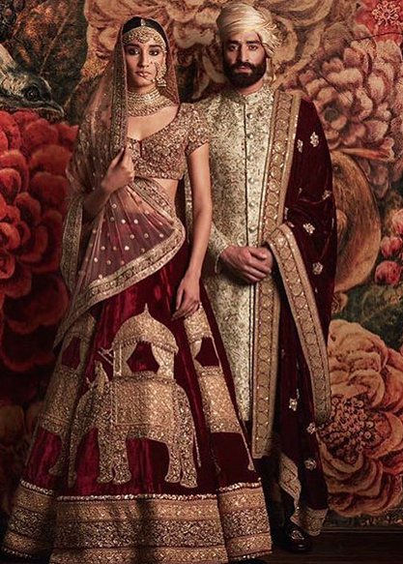

I’ve always been fascinated in Indian culture dresses. I love the beading on it and the intense amount of attention to detail that is apparent. In America, I think we just adopted the idea that a wedding dress should be white, but other countries were the first to introduce different colors. Indian wedding dresses, in particular, are worn in red or pink. The red dot is more of a culture thing and not necessarily set aside for brides but woman also wore a red dot on their face. A lot of fabrics and other goods were important to Europe from India. The Kashmir shawls are one example. The brides wore a sari or lehenga on their wedding day according to the region.

<https://www.boredpanda.com/most-beautiful-and-interesting-traditional-wedding-dresses-around-the-world/?utm_source=google&utm_medium=organic&utm_campaign=organic>

Textbook page 340

https://en.wikipedia.org/wiki/Indian_wedding_clothes

1. Example: Chloe Opdahl

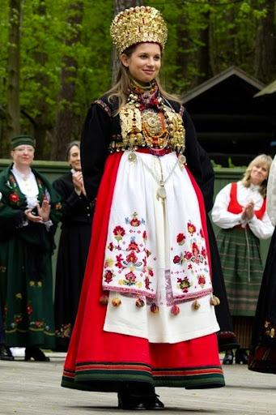

On my father's side of the family, their ancestors came down from Norway. I have never really thought about the culture of the wedding or any other aspects of Norwegians until recently, what I learned about the traditional wedding dress is fascinating. They are typically called a bunad, the rule of wearing a bunad is it serves as a public appreciation of and homage to your Norwegian heritage in general and to your town or region of Norway in particular. Though some devoutly traditional brides wear the traditional bridal bunad, a handmade dress of dark blue or black wool embroidered in traditional Norwegian decor. Every Norwegian bride wears a crown of gold or silver laced with spoon-like bangles. These bangles produce a melodic sound as the bride moves about, serving to ward off evil spirits.

Sources:

<https://www.lifeinnorway.net/bunad/>

[(Links to an external site.)](https://www.lifeinnorway.net/bunad/)

<https://eragem.com/news/norwegian-wedding-engagement-traditions/>

[(Links to an external site.)](https://eragem.com/news/norwegian-wedding-engagement-traditions/)

1. Irelynd Preece

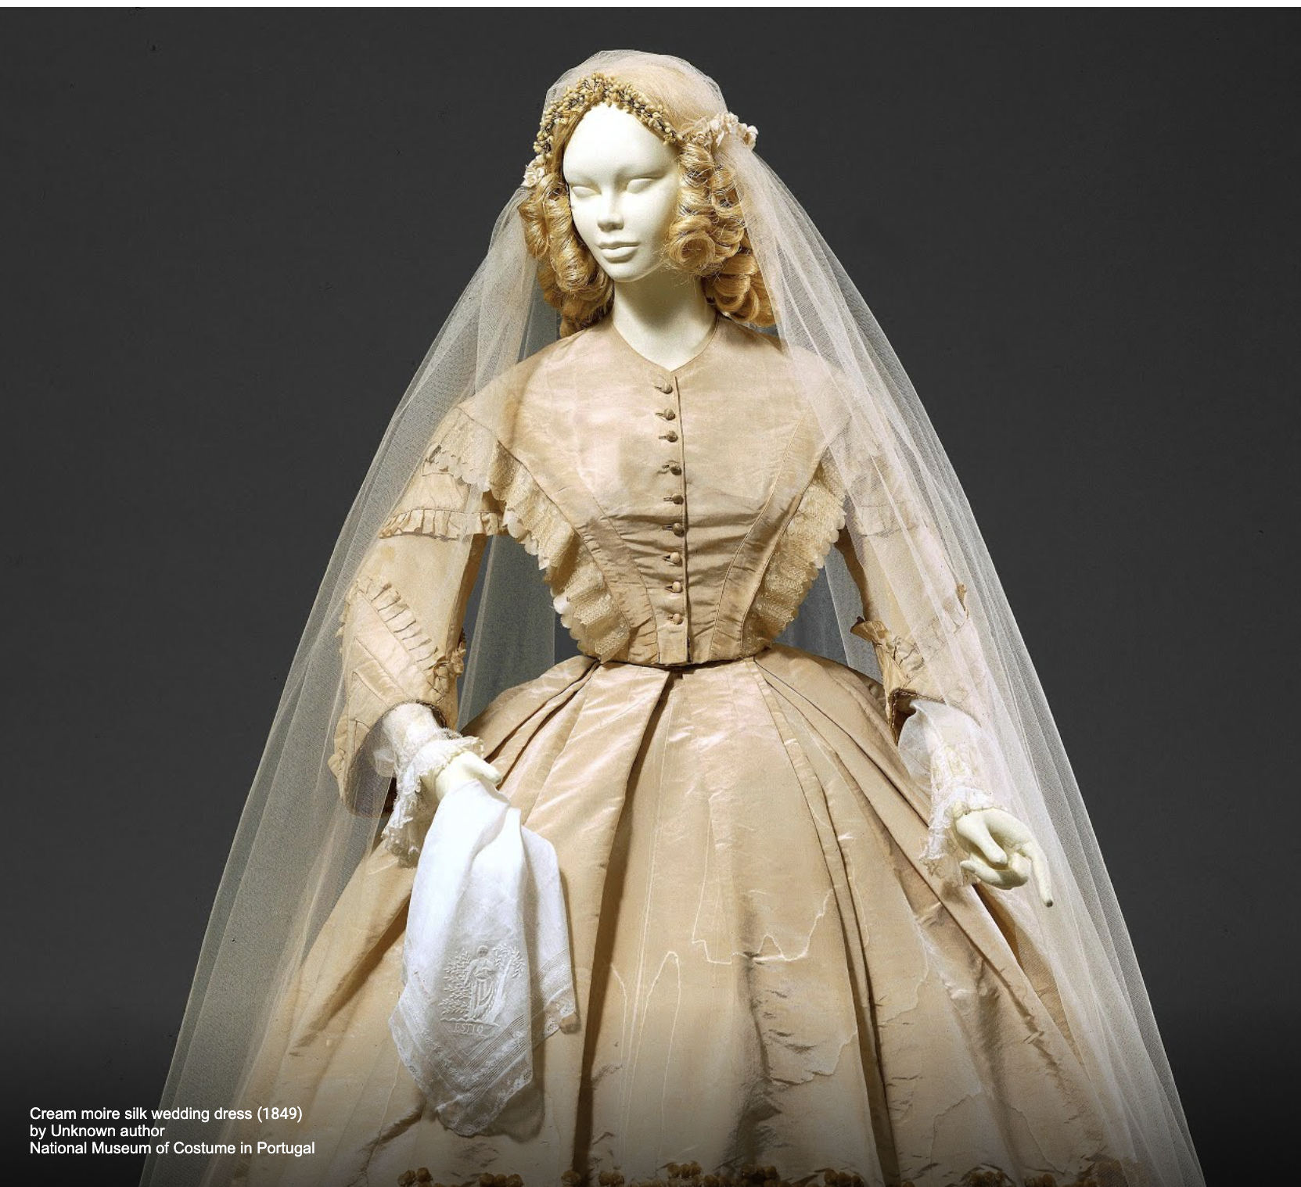

I have always been fascinated with Europe and turns out I actually have family from there on my dad's side as well! In this dress, I think the veil is so unique because it is very long, not like what we have today in American culture. I also love the lace coming off the sides of the woman's torso. This was a dress from the 1840-1860s in Portugal. I learned that the symbolism of the low neckline (or zeitgeist) is because this era has a "romantic" taste and it shows the importance of a wedding in the life of a girl. Another thing about this era with wedding dresses is that their dress is supposed to resemble a ball dress because it is a golden time in their life. Something that I found that was interesting is that in the 1800s only the wealthy people had a white dress due to that fabric being very expensive. So during this time in England wedding dresses actually consisted of many colors and styles that were often determined by wealth, material availability, and location. The wedding dress was often labeled as the womans "best dress".

Sources:

<https://artsandculture.google.com/exhibit/i-do-wedding-dresses-from-1800-2000-national-museum-of-costume-in-portugal/DAIyedOCJ8ljLw?hl=en>

<https://lilyabsinthe.com/wedding-fashions-of-the-late-19th-century/bridal-dresses-of-the-1870s/>

Hannah Ferreira

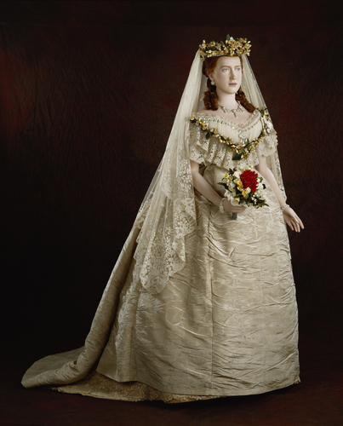

I looked at my family tree app and discovered I have quite a bit of ancestors from Denmark, so this is actually the wedding gown of Princess Alexandra who reigned as the Queen of the United Kingdom from 1901-1910. The Danish have many wedding traditions but as far as wedding gowns go, they mostly continued with the traditional white or ivory. However, this dress has one aspect that is particularly meaningful. The flowers around the bodice in the V shape and that form a crown for her veil are orange blossoms, these signify purity, innocence, chastity, and fertility. The white dress of course also symbolizes the purity and innocence.

<https://www.rct.uk/collection/71943/princess-alexandras-wedding-dress>

[(Links to an external site.)](https://www.rct.uk/collection/71943/princess-alexandras-wedding-dress)

<https://scandinavianshoppe.com/blog/scandinavian-products-danish-wedding-traditions/>

Jessica Fraser

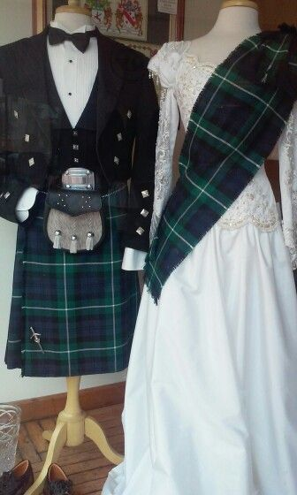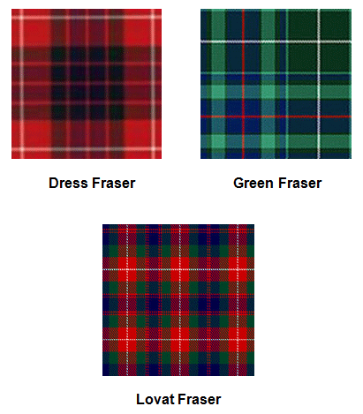

My last name comes from Scotland so I decided to research wedding dresses from Scottish history in the 1700's. Women would wear a plain white dress with little to no tartan to show their family line. Each family has their own tartan plaid that passes from generation to generation. Then men would wear a quilt or other symbol to show their family line as well.

I love the way that they keep tradition in a white pure dress, but they are able to bring their whole heritage into the simple plaid on her shoulder.

The women would make their own tartan hand spun. They would dye it very carefully to match their family line.

I went ahead and added my family's Fraser tartan. As you see they used different tartans for different events that they participated in.

<https://www.scottishtartans.co.uk/Isabella_Fraser_-_Wedding_Dress_c1785.pdf>

[(Links to an external site.)](https://www.scottishtartans.co.uk/Isabella_Fraser_-_Wedding_Dress_c1785.pdf)

<https://weddings.lovetoknow.com/wedding-traditions/wedding-history/traditional-scottish-wedding-dress>

**Savannah Jeppson**

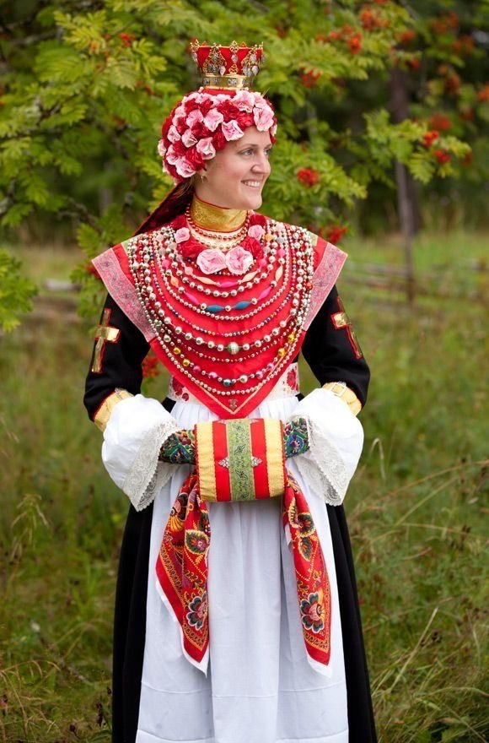

This is a traditional Scandinavian Wedding dress, but more specifically a Swedish wedding dress. My last name is a very common Swedish last name, and it is also where my Dad served his mission. A very common bridal accessory is the bridal floral crown. The crown is intricate, unique, and connects the different generations because they have been used for so long. It symbolizes the bride's purity and virginity at her wedding.

Sources:

<http://folkcostume.blogspot.com/2014/04/short-overview-of-traditional-bridal.html>

<http://weddingsallovertheworld.com/home/343-traditional-wedding-dresses-around-the-world-from-swedish-to-native-american-to-tunisian.html>

Brittany Pocock

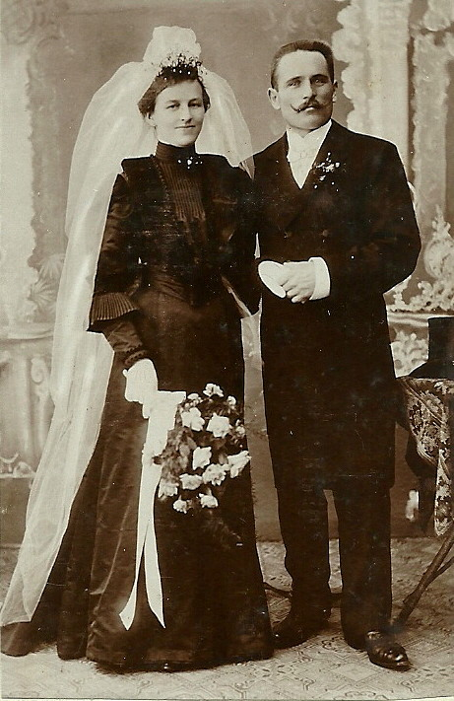

I have lots of German heritage, so I decided to research traditional German wedding dresses. Women would typically wear a black dress with a long white veil. They would wear black because the dress was used for more than one occasion and black was a color that they could keep clean easily. The veil was always long because the bride and groom would have a dance under the veil, at the end of the dance they would hold it up and then the women at the party would run to try and rip a piece from the veil. Whoever could rip a piece first was suspected to be the next bride.

History of the Black Wedding Dress – Kentucky Kindred Genealogy

German wedding traditions (iamexpat.de)

Madison Frost (Grider)

Looking at my family tree, I have some Native American ancestors. In this culture, the ceremony is usually at night. Part of the ceremony there is a washing where the water represents purification and cleansing. The bride and groom will wash their hands to wash away past evils and past loves. The wedding attire is called regalia, which represents royalty. After doing my research this "regalia'' all depends on your tribe. My ancestors were Cherokee. In this tribe, women wore a white dress and white moccasins. These dresses are made by pieces of cloth that were worn by other women and are made into squares or rectangles. This dress is called a "tear" dress. Today, you may see some dresses with a white calico pattern. Then men will wear a red shirt, with black pants and have an adornment of ribbons. Jewelry is also worn as a shield against evils.

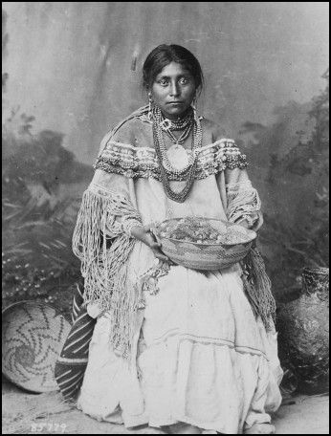

Sources:

<https://www.aaanativearts.com/cherokee-wedding-attire>

[(Links to an external site.)](https://www.aaanativearts.com/cherokee-wedding-attire)

[https://www.aaanativearts.com/cherokee-wedding-attirehttps://www.weddingdetails.com/native-american-wedding-traditions-how-to-stay-true-to-the-culture/](https://www.aaanativearts.com/cherokee-wedding-attire)

[(Links to an external site.)](https://www.aaanativearts.com/cherokee-wedding-attire)

Abigail Storrer

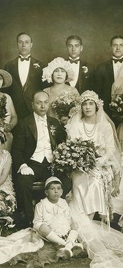

I have several ancestors that were from various parts of Italy. Though the main place they are from is Sicily. In Central Italy they traditionally wore black dresses. However, in other areas the dresses are white. In Italy the bride actually wore several dresses. The night before the wedding, the bride wore a green dress for good luck. In Sicily the ceremony was in the evening and the bride would arrive on horseback. While in other places the bride walked to the church. The wedding dress they wore to the ceremony for this reason was different from the one they wore to the reception. They saved the best dress for the reception. The brides also often had bags they carried with them that guests would put money in. Sometimes the guests would get a dance in exchange.

Sources

<https://www.lagazzettaitaliana.com/heritage/7640-italian-wedding-traditions-yesterday-and-today>

<https://www.pinterest.com/pin/251497960421996049/>

<https://www.exclusiveitalyweddings.com/italian-wedding-traditions.html>

Abby Fluckiger

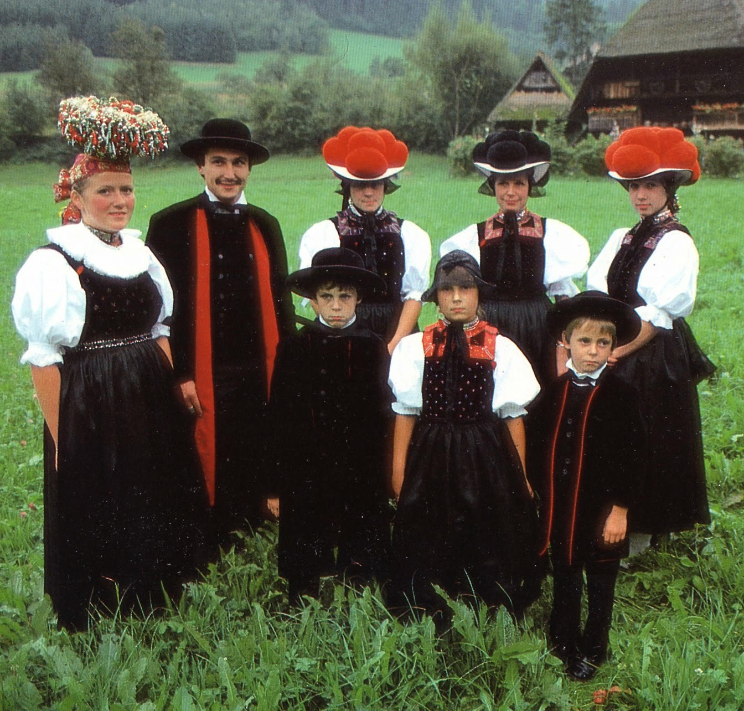

My family is from Switzerland, but I wasn't able to find anything -- at all -- on traditional Swiss wedding clothes, so I picked as close as I could. This photo depicts the tracht -- or folk clothing -- for a wedding in Gutach, Germany, which is in the province of Germany closest to Switzerland. The bride is on the left with the basket-shaped crown. These crowns would be adorned with ribbons, flowers, or painted glass balls, and would be passed through families, preserving tradition and good luck, since you had to ask for the crown and therefore the blessing of your family members before marrying. The bride also wears a black dirndl, which is the traditional dress for Germany and parts of Switzerland and Austria, with a white blouse, red bandanna (called a goldhaube), and black silk apron. The bride would have also worn brooches of silver, deer antler, or animal teeth.

This is just a bonus fact, but the three women on the right are also wearing tracht, with black dirndls, white blouses, and the hats with pompoms, which are called bollenhut. Besides being traditional, the hats' color also tells about the woman wearing it -- red pompoms mean she is unmarried, black means she is married. They're also exclusive to the Black Forest area, which borders on Switzerland.

Image: <http://folkcostume.blogspot.com/2014/04/short-overview-of-traditional-bridal.html>

[(Links to an external site.)](http://folkcostume.blogspot.com/2014/04/short-overview-of-traditional-bridal.html)

<https://en.wikipedia.org/wiki/Dirndl>

[(Links to an external site.)](https://en.wikipedia.org/wiki/Dirndl)

<https://en.wikipedia.org/wiki/Tracht>

**Marisa Lyn Bone**

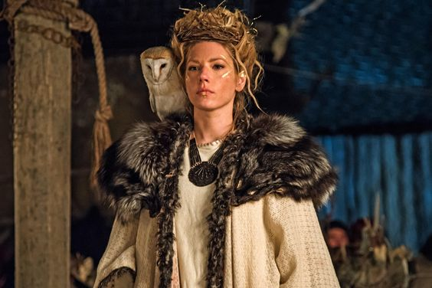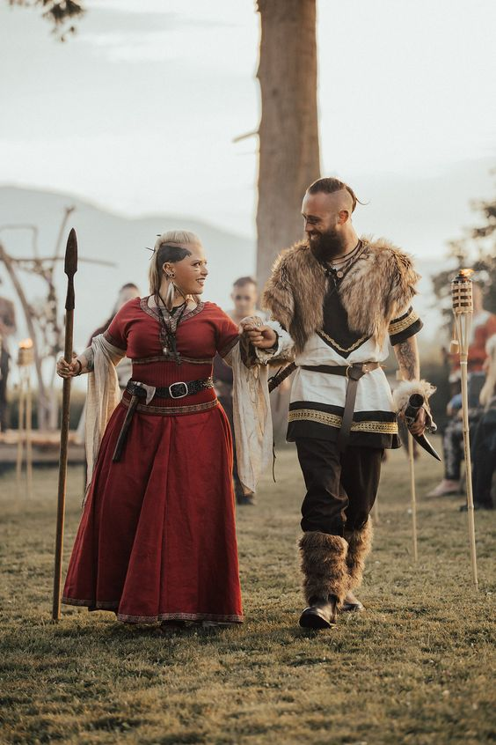

**Anglo-Saxon Wedding Dress**

**I've always been incredibly intrigued with my family ancestry, and on my dad's side we have been able to trace back to the Anglo Saxon era. Me and some of my relatives are able to speak the old Anglo tongue, and when I went to Iceland a few years ago; the cold winter air felt like I had connected to something ancient and benevolent in me.**

**"Viking" Wedding traditions begin with a connection to their Norse Gods, in which weddings are always held on Fridays, which is Frigg's Day or Freya's Day. The weddings would then last up and till the next week.**

**Vikings didn't exactly have ring bearers, but their rings would be resting on swords that they would trade with each other in the traditional sword trading ceremony. Their hands would be bound together with ribbons as they would say their vows.**

**And of course a feast would follow.**

**Bearing in mind that weddings were held outdoors, a wedding dress would be complete with multiple layers, and a fur lined cloak over the top. Where they would go all out though would be the hair, complete with a headdress or bridal crown of silver and crystal, straw or dried flowers.**

**Sources**

**:** [**Link 1**](https://www.routesnorth.com/language-and-culture/all-you-need-to-know-about-viking-weddings/)

**:** [**Link 2**](https://www.vikingsbrand.co/blogs/norse-news/viking-wedding-history)

Lauren Shumway

I have multiple Scottish clans in my family history. In Scottish culture, tartans, a wool Fabric woven in one of several plaid patterns, especially of a design associated with a particular Scottish clan, are an essential part of the culture. Most Traditional wedding dress in Scotland includes the bride wearing her husband tartan for the first time, symbolizing her transition into the family or clan. This tradition can range from the majority of a dress to a sash pinned at the shoulder with a brooch depicting a clan chest, thistle, or a Celtic knot. The dress pictured above is from 1785, but the fabric is older. This tradition leads to the dress that survives in a range of times eras from fashion.

<https://www.scottishtartans.co.uk/Isabella_Fraser_-_Wedding_Dress_c1785.pdf>

<https://www.boredpanda.com/most-beautiful-and-interesting-traditional-wedding-dresses-around-the-world/?utm_source=google&utm_medium=organic&utm_campaign=organic>

<http://www.tartansauthority.com/highland-dress/ancient/highland-dress-for-women/>

**Kimberly Tesam Moita**

**Kumeyaay traditional dress**

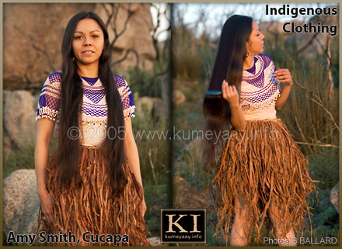

I am a half-native american, with my father being a full native from the Kumeyaay or Ipai-Ipai tribe. These natives are from the Mexi-Cali area of the US and northern Mexico. Traditionally for weddings, the tribespeople would wear their best clothing and weddings were arranged by the parents once their daughters and sons had reached puberty. Hair was long, worn in braids and or adorned with shells or feathers, capes and skirts of beaten willow bark that they would wear around their waists. They wouldn’t wear shirts, but they did paint their bodies and adopted more of the western clothing that pioneers and westerners wore near the 1800’s as America grew and expanded out West. The picture I have up here is of the skirt and a seed bead cape that was traditionally worn.

Sources: <http://www.kumeyaay.info/cocopah.html?http%3A//www.kumeyaay.info/cocopah/bark_skirt.html> , <https://www.nps.gov/cabr/learn/historyculture/kumeyaay.htm> , <http://what-when-how.com/native-americans/tipai-ipai-native-americans-of-california/>

**Samantha Hooper**

For my traditional wedding dress, I opted to look into Polish wedding traditions. Traditional Polish dresses are very colorful, often embroidered with flowers that match the groom's attire. White is used but is not the main color as white symbolized Christ to the Polish, rather than purity as it did in other cultures. The bride's headdress is a main focal point of the bridal look- these floral headdresses were made by women in a bride's community, often taking several days to assemble. At midnight on the wedding night, the headdress is removed to symbolize the end of childhood and the start of a bride's adult married life.

Sources: <https://warsawinsider.pl/13350-2/>

https://culture.pl/en/article/polish-weddings-then-now

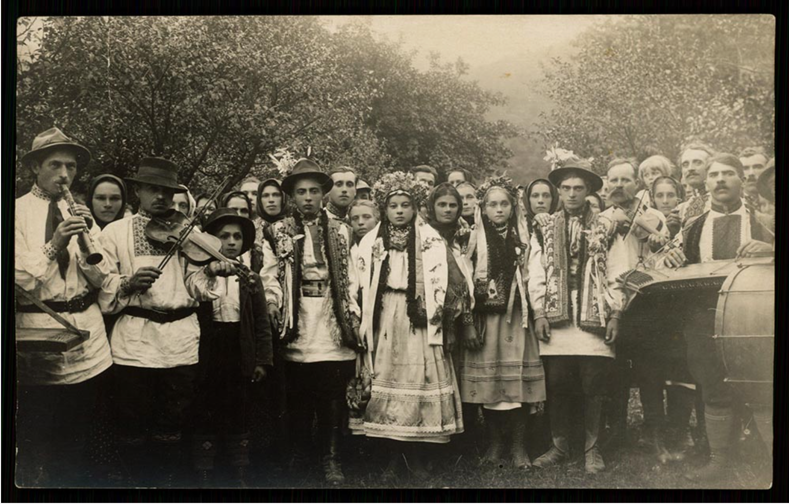

Ida Johnson

The Norwegian Traditional Folk Wedding dress is called a Bunad. This includes a bridal crown worn during the wedding made by the bride's family, and handed down through the centuries. Children are often not invited to these weddings, and they are usually small affairs with only family attending. The term Bunad is best understood as referring to Norwegian traditional clothing, and it includes a variety of regional styles. In general, Bunads are colorful garments made of wool and adorned with embroidery, buckles, shawls, scarfs, and traditional, handmade Norwegian jewelry known as solje. Although Bunads may look similar across various regions, each Bunad is meant to incorporate the unique traditions and designs of the community it represents.

The Bunad is a result of Modern times. After Norway obtained independence on 17 May 1814, the Norwegian people sought to revive the unique identity and heritage of Norway. This effort led to developing a new written Norwegian language, publishing Norwegian folktales, and recovering Norwegian traditional clothing.

<https://viola.bz/norwegian-bridal-crowns/>

<https://www.familysearch.org/en/blog/bunad-traditional-norwegian-dress>

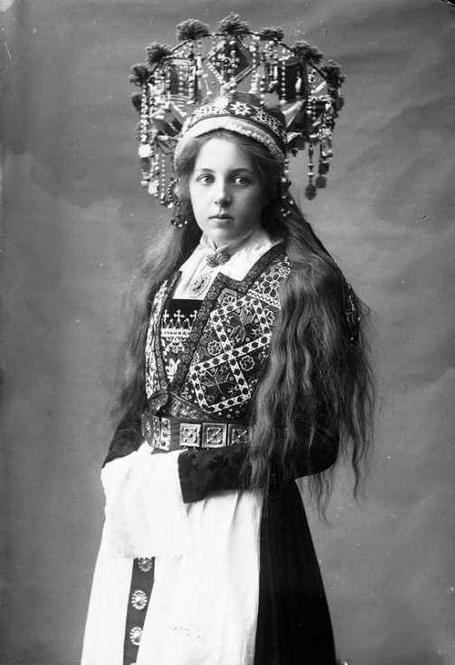

**Ryann Becker**

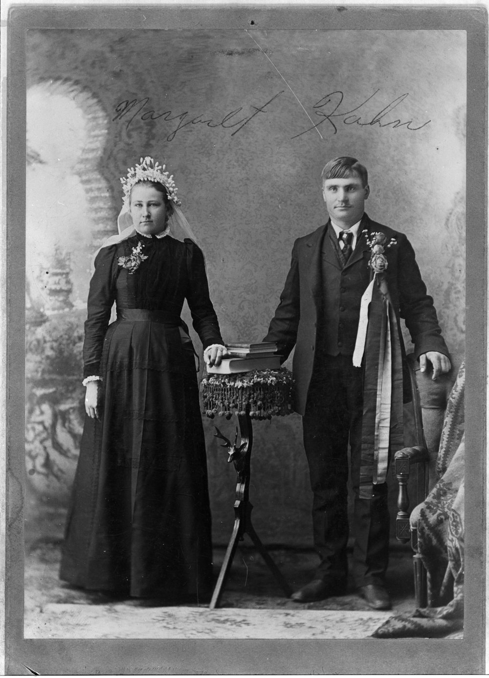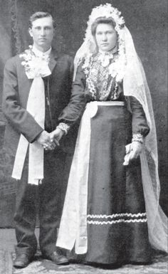

My great-grandma on my dad’s side was German. Her name is Gretchen, I was named after her. It is my middle name. I have other ancestors on my mom’s side who are German as well. This is why I choose a traditional German wedding dress. As shown in these two pictures, the dress was traditionally black and they wore a white veil. If the dress was a darker color it would get dirty less easily and they could wear it on other occasions. Today German and American brides commonly choose a white wedding dress. We also only wear the dress once. I thought it was smart to be able to wear the dress repeatedly.

<https://www.weddingshoppeinc.com/blogs/weddings/german-wedding-customs>

<https://www.iamexpat.de/expat-info/german-expat-news/german-wedding-traditions>

**Andrea Lazaro Hernandez**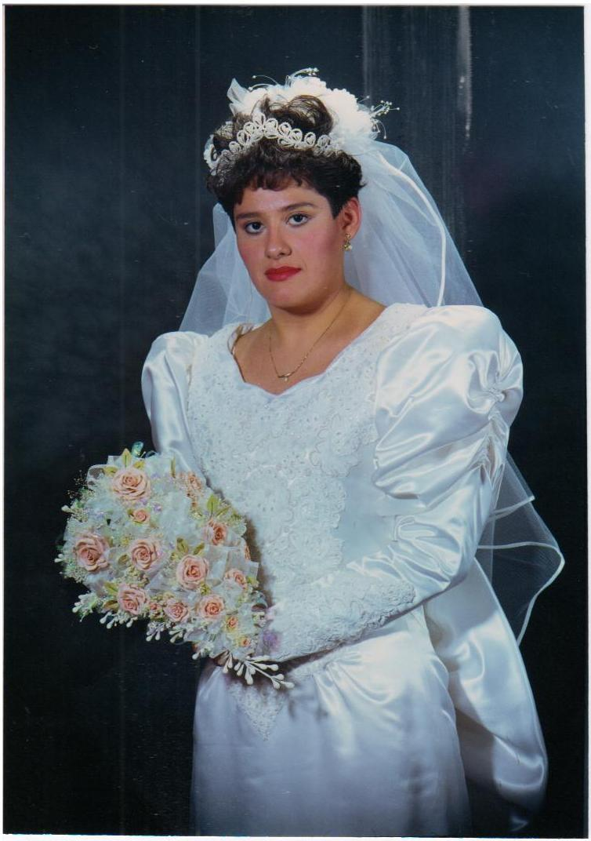

Hi! I am from Mexico, and there are different indigenous groups around the country, and also many different traditions too, so it was a little hard to pick one traditional dress. As I was researching, I found out that some of the wedding dresses that are most commonly worn in Mexico are influenced by the Spanish people who conquered Mexico over 300 hundred years ago. My great grandparents were from Spain, so I thought it would be interesting to share both the Mexican and Spanish tradition. First, it is a tradition in Mexico that the groom gives the money to the family of the bride to make the wedding dress. All the dresses are different according to what the bride wants, but most of them include Mexican elements like embroidery or a mantilla veil. Some brides wear boleros, ruffles, or some more flamenco inspired details from Spanish culture. In the picture you will appreciate my mom wearing her wedding dress. It was made by her aunts, and embroidered by her grandmother, following what my mom requested for the design.

Sources:

<https://www.linandjirsa.com/mexican-wedding-traditions/?fbclid=IwAR2KjR9WJXEPKhNsHyENgCnna8-rMn4fQwPvP-IxNzZ_0hPPXKbo9_qNc60>

[(Links to an external site.)](https://www.linandjirsa.com/mexican-wedding-traditions/?fbclid=IwAR2KjR9WJXEPKhNsHyENgCnna8-rMn4fQwPvP-IxNzZ_0hPPXKbo9_qNc60)

<https://weddings.lovetoknow.com/wedding-traditions/traditional-mexican-wedding-dresses>

***Jensen Stenquist***

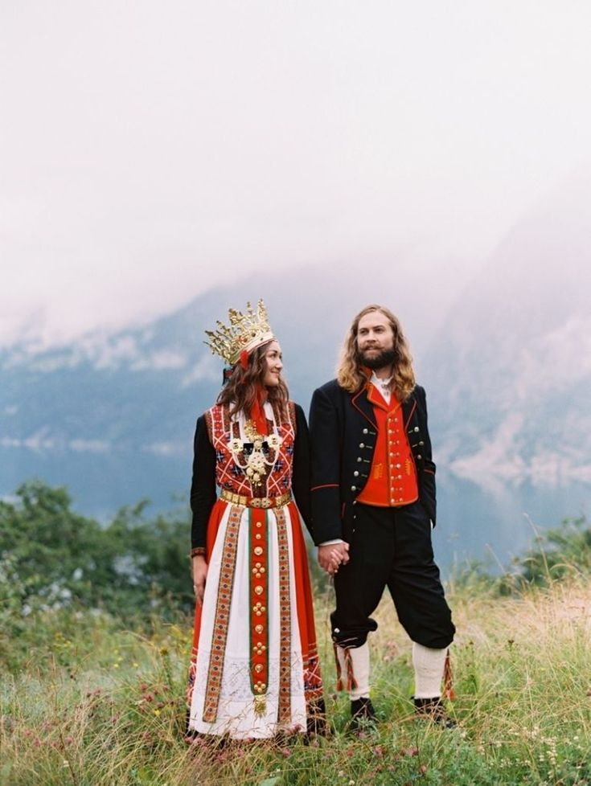

***My dad's grandpa came over from Sweden when he was 6 years old. They had to change their last name when they came. I believe it was Nielsen before it was Stenquist. I honestly don't know how that name even changed.***

***I learned from reading about traditional Swedish wedding dress that a Swedish bride will wear three bands, one for her engagement, one for marriage, and one for motherhood, she will also wear a tiara to symbolize her virgin status, although in the past these tiaras were actually crowns made of myrtle leaves. The crown is the most important part of the attire. There are many layers in the traditional wedding dress. They will usually have complimentary jewelry with silver jewels.***

***<https://www.beau-coup.com/swedish-wedding-traditions.htm>***

***[(Links to an external site.)](https://www.beau-coup.com/swedish-wedding-traditions.htm)***

***<https://ingebretsens-blog.com/swedish-wedding-traditions/>***

***[(Links to an external site.)](https://ingebretsens-blog.com/swedish-wedding-traditions/)***

**Emma Lewis**

**My family is originally from England. When researching traditional English wedding dresses I discovered a large portion of traditional gowns are not the white or cream color we associate with weddings. Women would typically just wear their best dress for their wedding, which usually wasn't white. Dresses were not commonly made for the sole purpose of weddings, they were often colorful or patterned and don't resemble what we know as a wedding dress today. White symbolizes purity and was usually worn by the wealthy. White was not associated with weddings until Queen Victoria's wedding in 1840.** 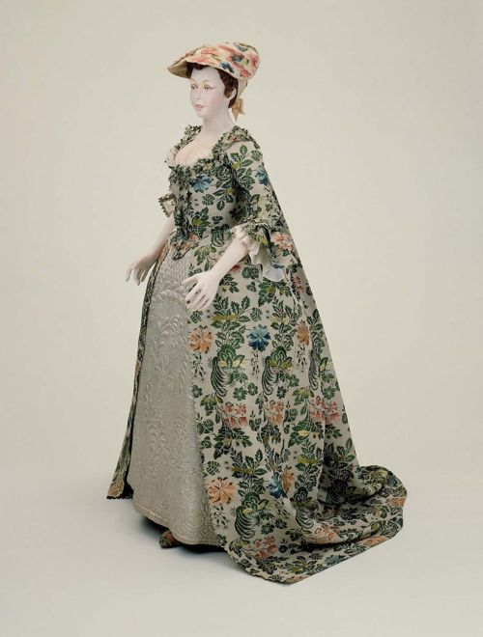

**Sources:**

[**https://lilyabsinthe.com/wedding-fashions-of-the-late-19th-century/bridal-dresses-of-the-1870s/**](https://lilyabsinthe.com/wedding-fashions-of-the-late-19th-century/bridal-dresses-of-the-1870s/)

[**https://thedreamstress.com/2011/04/the-18th-century-wedding-dress-then-and-now/**](https://thedreamstress.com/2011/04/the-18th-century-wedding-dress-then-and-now/)

**Amanda Hair**

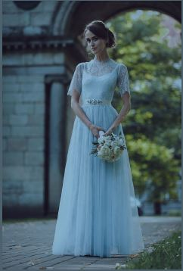

I have Irish relatives on both my mom and dad’s side of the family and my husband also has irish relatives. As I looked more into their culture and traditional weddings I found that traditionally brides wore a blue wedding dress . Blue was chosen because it was the color symbolising purity before white became known for symbolizing virginity. Today brides there don’t always wear blue dresses but it’s still a well known tradition. Irish weddings are said to be, “some of the most romantic and soulful weddings to attend” because of the rich tradition. Some of these traditions have continued such as wearing a veil or carrying beautiful flowers, but others like only getting married at certain times of year or eating salt on the wedding day have been left behind.

**Sources**

<https://www.brides.com/irish-wedding-traditions-4800060>

<https://www.ouririshheritage.org/content/archive/topics/st_josephs_secondary_school_castlebar_co_mayo/old_irish_wedding_traditions>

Debbi Wright

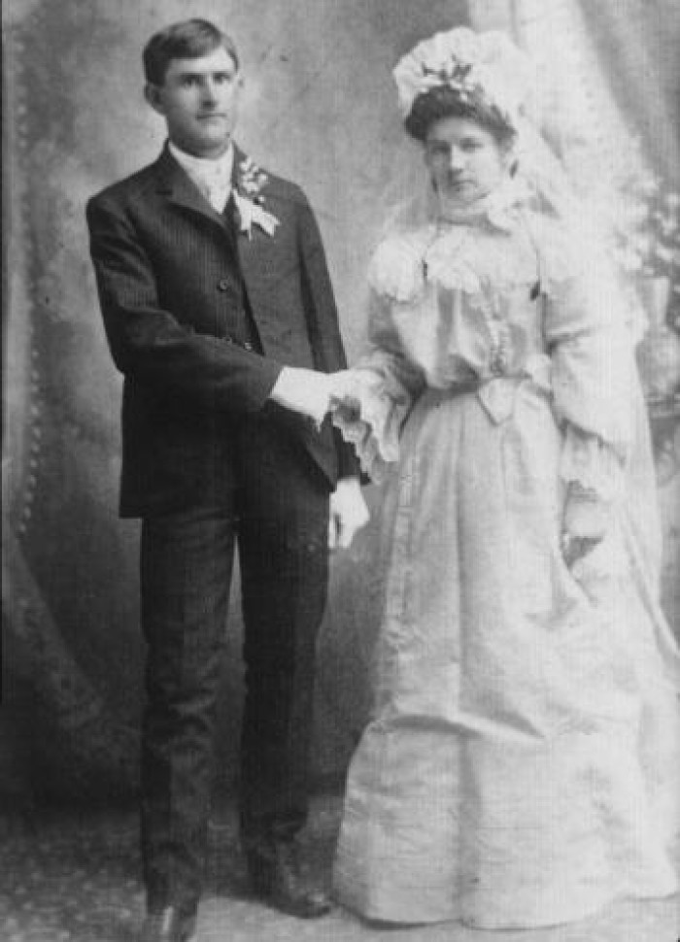

My great grandmother Antonia Rewaldt, was Bohemian which was a way of life in the 1800's, she was also from an area called Bohemia. At some point during the war and with very liquid borders the area now is known as Czechoslovakia.

Following is a quote from the Portal to Texas History, "Photograph (copy) of "Czech Wedding dress" as type written on back of photo. The groom is holding the bride's right hand in his right hand. Man is wearing a dark stripe three piece suit with boots. He has a white shirt and tie, gloves, and a flowers tied with ribbon on his lapel. Bride is wearing a long white dress with high lace neck and layer of lace that drapes around shoulders. Sleeves have gathered lace extending from elbow to wrist. She is wearing gloves and a headdress that puffs on top of her head and has tulle that hangs down her back and past her knees. " I didn't find anything that tells what the symbolism of the different parts of the dress mean.

However, I did learn about some of the other wedding traditions from a website, Beau-Coup.com. The bride would wear a rosemary wreath about her head. This symbolizes wisdom, love and loyalty. There is the tradition of wearing something old, new, borrowed and blue. The borrowed item must be from a friend who is already married. The old item must be a family heirloom.

Friends of the groom hang a rope decorated by flowers, ribbons, and empty bottles, then the groom must pay his friends to pass through the rope and pay himself out of the sins of his youth. Throwing rice was meant to ensure fertility.

At the beginning of the reception, someone would break a plate at the feet of the couple. They would sweep the broken pieces to symbolize happiness and show a willingness to work together. Another tradition happens at dinner when the bride and groom share a bowl of soup with one spoon. This also symbolizes the willingness to work together.

During the reception the groomsmen kidnap the bride. The groom needs to find her within a certain amount of time, if he does not he will have to buy her back. This symbolizes that he promised to care for and protect her. After the Czech wedding song, the veil of the bride and the groom's shoes are filled with money from the guests to help pay for the honeymoon.

<https://texashistory.unt.edu/ark:/67531/metapth828/m1/1/>

[(Links to an external site.)](https://texashistory.unt.edu/ark:/67531/metapth828/m1/1/)

<https://www.beau-coup.com/czech-wedding-traditions.htm>

[(Links to an external site.)](https://www.beau-coup.com/czech-wedding-traditions.htm)

Claire Moore

I decided to do some research on the traditional Irish wedding dress since some of my family originated from there. The most popular and common theme with traditional Irish wedding dresses are lace. Dresses were often completely lace and were specifically made mostly of "Irish Lace". This lace was seen as luxury and high class. As you can see in the example picture below this dress is all lace. Another common tradition that Irish brides did was have a blue wedding dress. Blue to them was the color of innocence and purity.

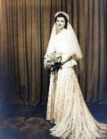

sources

<https://www.ireland-information.com/articles/irishweddingtraditions.htm>

[(Links to an external site.)](https://www.ireland-information.com/articles/irishweddingtraditions.htm)

<https://www.ouririshheritage.org/content/archive/topics/st_josephs_secondary_school_castlebar_co_mayo/old_irish_wedding_traditions>

Jalissa Cloward

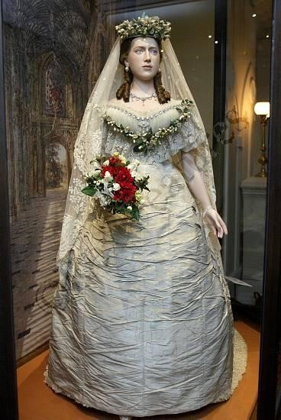

In Denmark, white is still the color to be worn on your wedding day to symbolize purity. However, unlike our “something blue”, Danish customs have the bride wear something red. Red is the color of love, and it was believed to ward off evil spirits. An important part of the bride’s ensemble was the veil. Throughout the ceremony, the bride wears her veil to ward off any evil spirits. Later the veil is torn up by the wedding guests. Each of the guests take home part of the veil as good luck.

<https://scandinavianshoppe.com/blog/scandinavian-products-danish-wedding-traditions/>

<https://www.eventdone.com/blog/188-danish-wedding>

Alex Clark

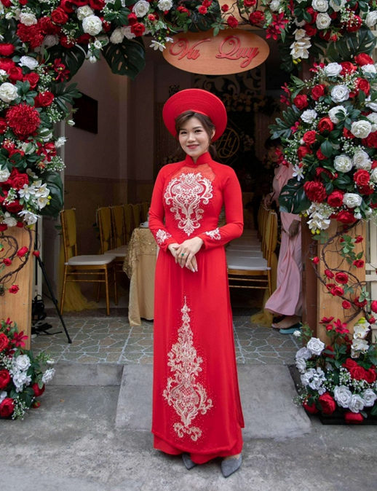

For my traditional wedding dress, I decided to look into the traditional dress of a Vietnamese bride. From my research I have learned that the traditional grab is called an áo dài. The áo dài is a traditional grab used in multiple ceremonies besides weddings. The coloration of the dress tends to be a shade of red, this is to show happiness, luck, and prosperity. Underneath the áo dài, a bride is usually fitted with loose pants to go with it. In some instances, the áo dài also has the groom’s animal of the year incorporated into the dress. In order to connect to the person, they are marrying. The dress is also usually fitted with a headpiece called the khăn vấn which is usually bigger and more extravagant than the grooms. The khăn vấn is also usually matched with the áo dài that the bride is wearing.

Sources

<https://www.theknot.com/content/vietnamese-wedding-traditions>

<https://en.wikipedia.org/wiki/Traditional_Vietnamese_wedding>

<https://eastmeetsdress.com/blogs/blog/the-5-essential-elements-of-a-bridal-ao-dai>

<https://marknvy.com/products/red-wedding-ao-dai-beautiful-made-to-measure-vietnamese-dress-with-spectacular-gold-details>

Jamie Rakes

So on my fathers side he is part Native American so I wanted to look into that for this assignment. My ancestors were Cherokee Indian and I was able to find out so many interesting things with traditional wedding wear!

a traditional wedding dress for them was called a tear dress and was usually made out of white or ivory scrap or torn fabric as they didn’t have scissors.

there is also a blue blanket that is placed on the shoulders of both the bride and groom that represents the sadness and trials they have walked through up to this point. After this a white blanket is placed on top of the blue blanket of both the bride and groom to show unity and and peace and to cover up the shame and sorrow of their past as they are now joined together. And that is what closes the ceremony

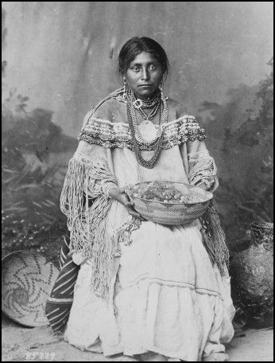

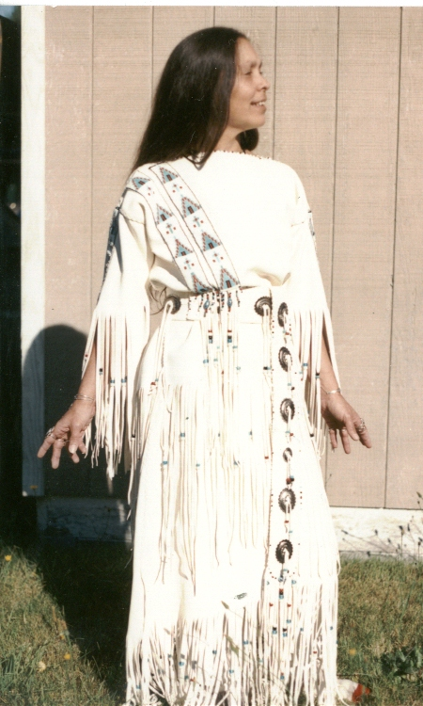

https://eragem.com/news/cherokee-wedding-ceremony-customs/

<https://www.google.com/amp/s/www.aaanativearts.com/cherokee-wedding-attire/amp>

**Lexie Pincock**

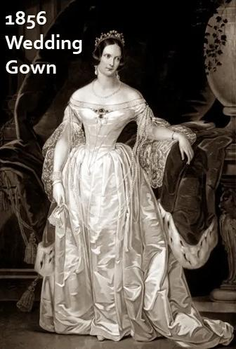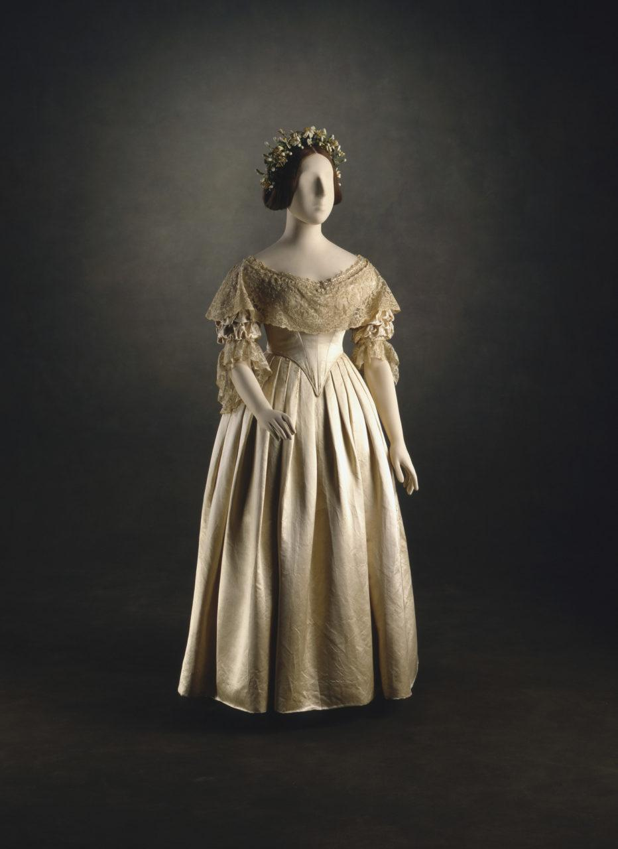

My family is originally from England. I have always loved the layers and lace from their gowns. The dresses back then gave an indication of wealth. Not everyone wore white dresses, it was considered expensive and impractical because of the upkeep and the need to wear garments more than once. So white wasn’t very popular and more expensive. Status was also indicated by the length of the train on a dress, the longer it was the more wealth you had.

**Sources:**

<https://fashionhistory.fitnyc.edu/1840-queen-victorias-wedding-dress/>

<https://bellatory.com/clothing/sewing-vintage-wedding-gowns>

**Savannah Tanner**

I have family from all over but I decided to go with a French wedding dress. The specific wedding dress example I chose is from 1896. During that time period it was common to use a steel-boned corset to accentuate the hourglass figure of the bride. Around this time period it was also customary to wear white wedding dresses. This tradition was common after Mary Queen of Scots married the King of France in 1558, before that time period, white was seen as a color of mourning for French Queens. The color white became a status symbol, as they were harder to keep clean. Following the industrial revolution, however, they became much more common and became a one-time use article of clothing. For the specific wedding dress I chose, the textile garment compliments the wearer instead of utilizing lace details.

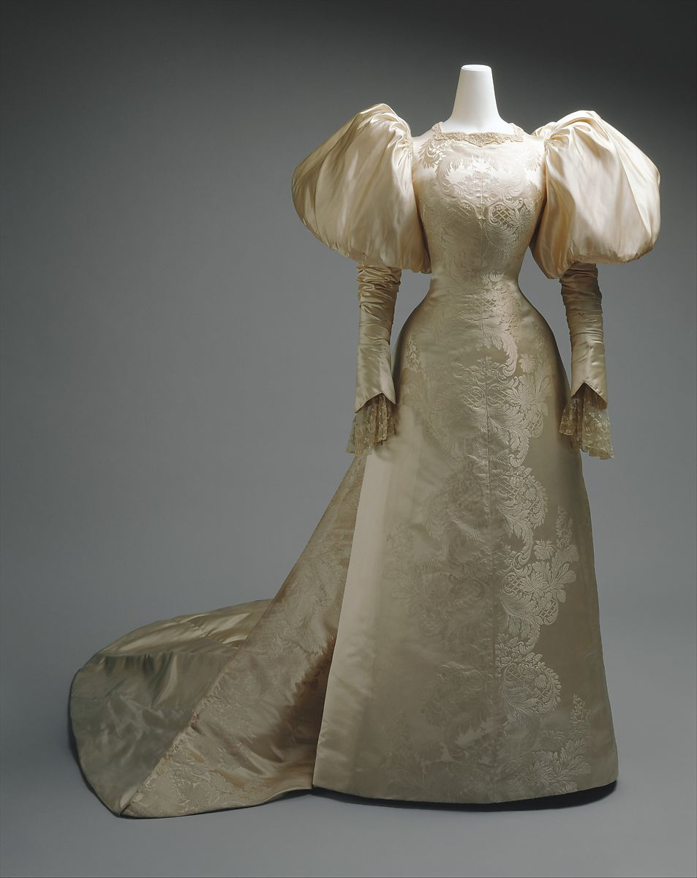

<https://candicehern.com/regencyworld/french-bridal-dress-august-1823/>

<https://www.metmuseum.org/art/collection/search/81467>

<https://daily.jstor.org/a-natural-history-of-the-wedding-dress/>

Marisol Dejesus

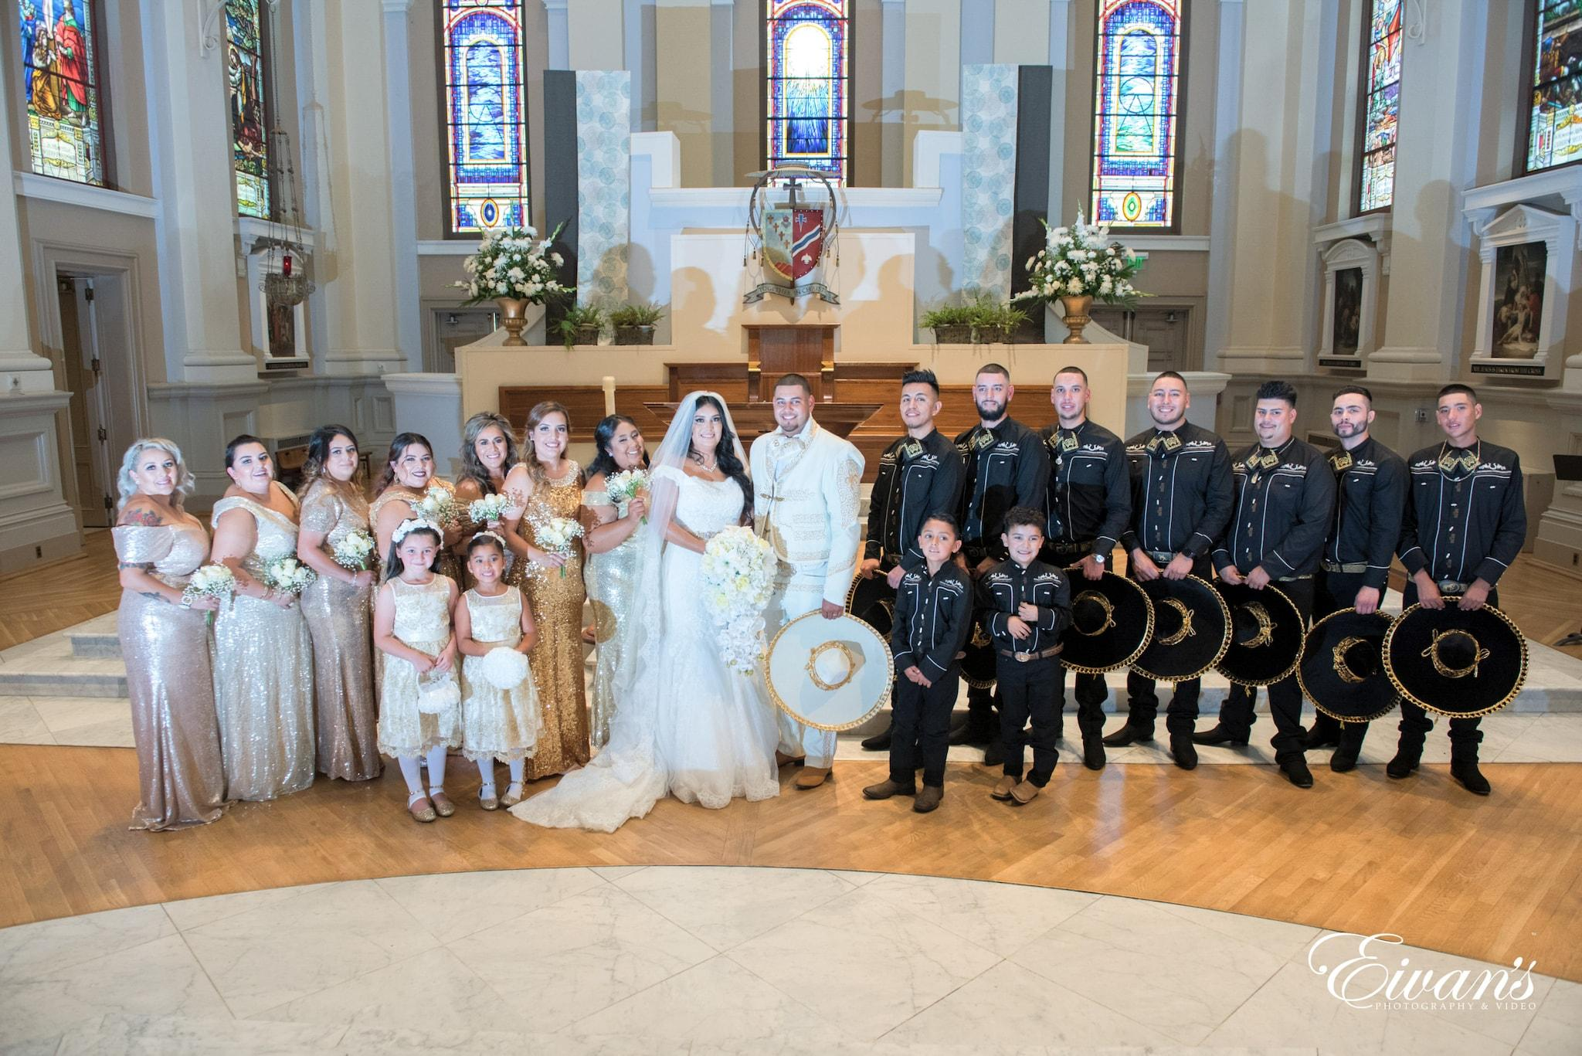

My family is Mexican. One thing I learned about Mexican traditional wedding dress is that their dresses had evolved over the years because brides would wear different varieties of styles. Nowadays the bride will wear a modern dress with a touch of Mexican elements. The bride's wedding dress symbolizes good luck, prosperity, and fertility. For the groom they wear a guayaberas, which are Mexican shirts and pants. However, the groom can wear a suit to their wedding. Then we have padrino(godparents) who provide financial support to help us with wedding expenses.

Resource:

<https://www.linandjirsa.com/mexican-wedding-traditions/>

<https://www.eivans.com/mexican-wedding-traditions/>

**Abbie Burns**

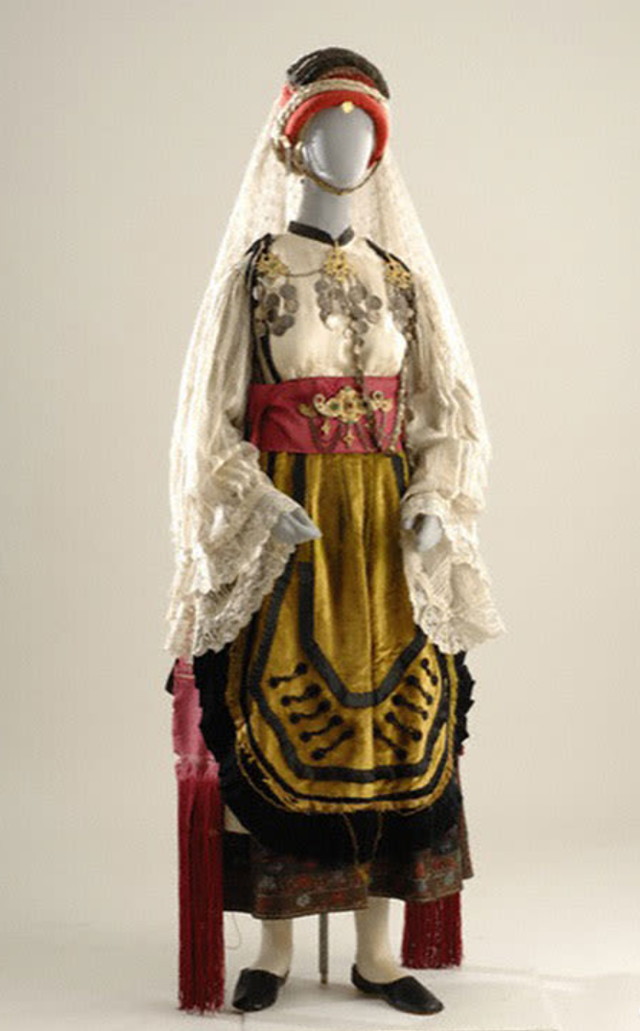

I come from a line of Greek heritage. Greeks are known for believing in mythology. Ancient Greek women would wear red or yellow veils to warn off evil spirits. Wedding dresses were a representation of the bride's family and were represented through layers of clothes, particular fabrics and symbols. Most traditional wedding dresses were hand made with the finest fabrics. Brides who lived in more urban areas had accents of gold to their dress attire. Brides in villages wore bright colors, mainly red. Traditionally a headdress would be worn and a gold plated belt making the bride's day a rather heavy one. Most traditional Greek wedding dresses varied in style due to material, region, and fabric available. One thing they all had in common was the over accessorized look. The abundance of jeweler on a bride represented the wealth of one's family. Diamonds were worn to represent the tear drops of Gods ``reflecting the flames of love."

<https://www.manhattanbride.com/insights/greek/>

<https://www.europeana.eu/en/blog/folk-greek-bridal-gowns-the-evolution-of-greek-bridal-couture>

**Jocelyn Munoz**

So on my dad’s side I’m Peruvian so I decided to look more into that sort of wedding culture. Since I’ve never actually attended a traditional Peruvian wedding ceremony I’m not sure this is one-hundred percent true but it’s what I found online.

While nowadays people combine western wedding culture and their own, traditionally it’s all about color. According to an article I found the colors and patterns used through the bridal costumes is used to represent the power of the Incan Empire, the symbolism also influences the decor. I also shared a more modern picture because I think the way they incorporate old traditions is so beautiful.

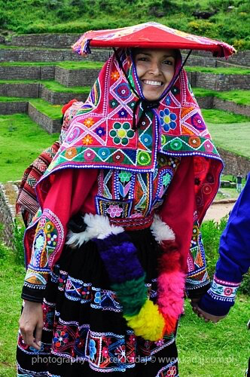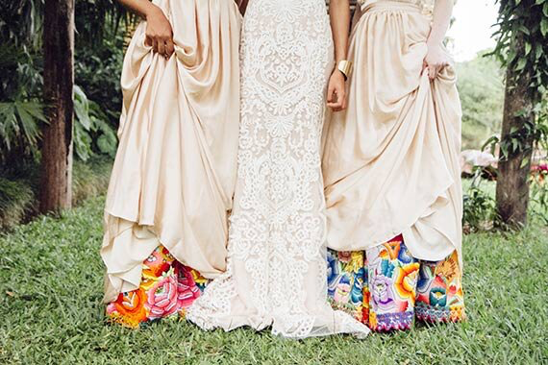

Sources:

https://www.nkbride.com/blog/2019/12/17/wedding-costumes-around-the-world-peruvian-brides

https://www.weddingdetails.com/a-guide-to-peruvian-wedding-traditions/

**Bailey Pinder**

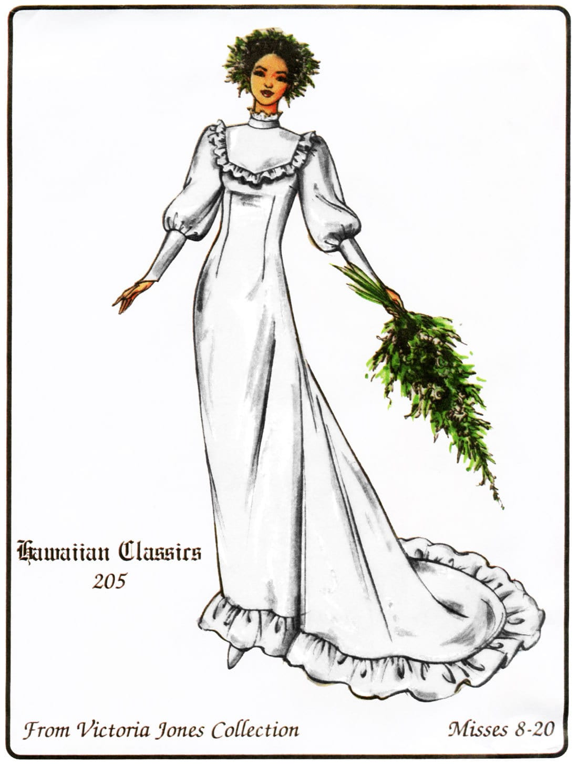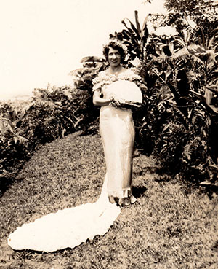

My grandma is Hawaiian and so I decided to research examples of traditional Hawaiian wedding clothing. These pictures are two example of a holokū. They are formal Hawaiian dresses with a very interesting history. For thousands of years in the Hawaiian nations there was nothing quite like what what we know today as a wedding. Nothing like that was practiced in Hawaii until Europeans arrived in the islands, bringing Christianity and contemporary clothing. In 1820 the ship Thadeus arrived in Hawaii carrying Christian missionaries and when the widow of King Kamehameha learned that there were women aboard the ship she could not wait to learn what the fashions of Europe were. The women aboard taught the attendants how to construct a simple day gown and from there the fashion continued to evolve. Some holokū have long trains and many ruffles and some are more simple. They can be simple or loose, made of tropical print fabric or plain.

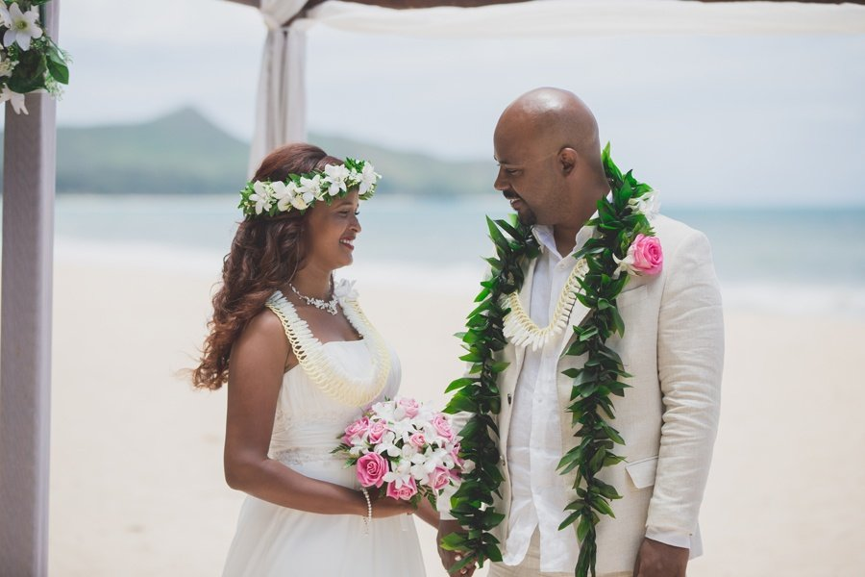

Another important part of Hawaiian wedding tradition I need to mention are leis. Even before European contact leis were very important in many traditional ceremonies. At a wedding today it is common to see both bride and grooming wearing maile leis (the lei made out of the green leaves that is draped over the mans shoulders is a maile lei.) Another very common lei to see at a wedding (and my favorite kind of lei) is a haku. The haku is worn around the head and can be made of maile or a variety of other flowers. Leis are exchanged by the couple on the wedding day.

<https://keolamagazine.com/culture/the-holoku/>

<https://www.kaahelehawaii.com/ho%CA%BBao-hawaiian-weddings/>

Claire Lynes

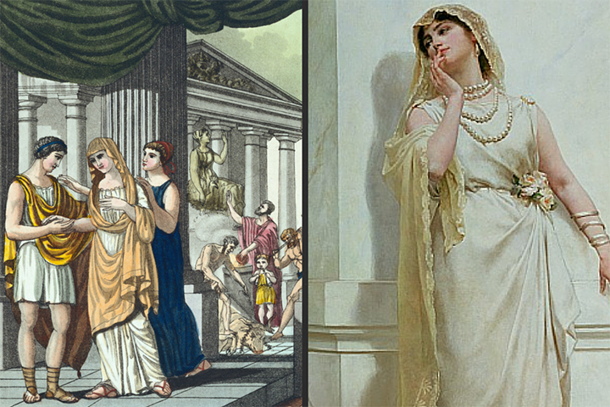

​​My mothers side of the family is very Italian. So, as I began to look into the wedding traditions of Italy, I started looking into ancient Rome and what the traditions of that time were.

In ancient Rome the brides wore a white robe that was called a tunica recta. Then there would be a woolen girdle worn. This girdle was tied with a special knot by the bride's mother. The knot was called "the Knot of Hercules” and could only be undone by the groom. This is where the saying "tying the knot" came from. The bride would also wear a veil that was a yellow/golden/red color that symbolized fire. This veil would not cover the brides entire face. And originally there was no jewelry worn but as time passed the brides began to wear gold jewelry.

<http://www.tribunesandtriumphs.org/roman-clothing/roman-wedding-clothing.htm>

[(Links to an external site.)](http://www.tribunesandtriumphs.org/roman-clothing/roman-wedding-clothing.htm)

<https://www.explore-italian-culture.com/ancient-roman-bridal-fashion.html>

[(Links to an external site.)](https://www.explore-italian-culture.com/ancient-roman-bridal-fashion.html)

[Reply](https://byui.instructure.com/courses/168708/discussion_topics/5266750#)

[Reply to Comment](https://byui.instructure.com/courses/168708/discussion_topics/5266750#)

# Aubrey Reidhead

My family, like several others here, is of Scottish descent. The lineage is quite literally how my family got our last name. We used to be called the Redheads for many generations, but language and annunciation evolves and tweaks names over time and that is where my last name comes from.

The source that I found on traditional Scottish weddings mentioned that the original wedding dress is called and Arisaid/Earasaid. It “resembl(ed) a hooded cape, it is tied at the waist. It was usually adorned with simple, pale stripes.”(Kilts-n-stuff) The tartans were used, but they were pale colors or simple designs leaving the daring colors for their husbands. If the bride were to wear a colorful one, then they were considered to be a harlot and would be respected and viewed as such. (Love To Know)

Clan was a huge thing and still is of utmost importance to be respectful to both clans being wed. The colors used and patterning is carefully chosen to honor the legacies of the clans.

<https://www.kilts-n-stuff.com/scottish-wedding-traditions/>

<https://weddings.lovetoknow.com/wedding-traditions/wedding-history/traditional-scottish-wedding-dress>

Remi Giffin

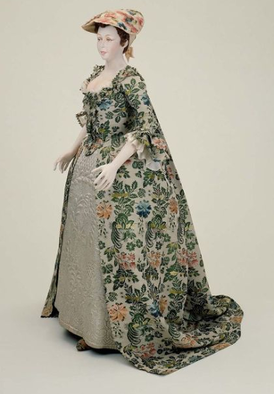

My family has ties to England pre-dating the popularization of white dresses during the nineteenth century. Before white gowns were made popular by Queen Victoria in 1840, England had completely different traditional wedding attire. Traditionally women would dress in brightly colored dresses with many details and patterns. The opulence of the dress reflected the wealth and the length of preparation of the wedding. Patterned fabric was becoming cheaper and middle class women could acquire fashionable fabrics for their gowns. The neckline of traditional gowns were low to expose the neck, but as time progressed they would rise to increase modesty. White was worn during mourning so women opted for more colorful dresses. The color of English womens’ dresses determined their elite fashion status with blue dresses signifying popularity. Traditional dresses were made to be worn again and again when the occasion called for it. If money was sparse many poor women would be married in the best dress they already own reflecting the spirit of the times.

[http://ultimatehistoryproject.com/before-the-whiteout-wedding-dresses-and-grooms-outfits.](http://ultimatehistoryproject.com/before-the-whiteout-wedding-dresses-and-grooms-outfits.html)

<https://daily.jstor.org/a-natural-history-of-the-wedding-dress/>

Hailey Child

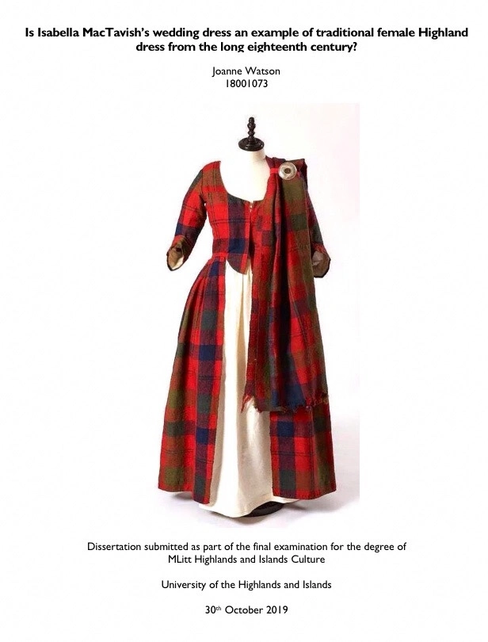

My mothers maiden name is Bruce, coming from King Robert the Bruce from Scotland. Their clothing is pretty much what I had pictured in my head when I pictured traditional Scottish wedding attire. However, something interesting about the classic plaid pattern is that the colors and direct patterns differ for each "clan". The tartan (or plaid cloth) must be properly designed to the clan you belong to. The woman wears a floor length pale dress with a tartan shawl over. While the men wear the well known kilt in his clans more colorful tartan design. In modern day, these traditions are carried over and woman can be seen wearing a traditional pale white dress paired with a tartan corset, tartan sash, or even a tartan cape over.

<https://weddings.lovetoknow.com/wedding-traditions/wedding-history/traditional-scottish-wedding-dress>

<http://nationalclothing.org/europe/16-scotland/9-national-dress-of-scotland-men-s-and-ladies-kilt.html>

Sariah Beverley

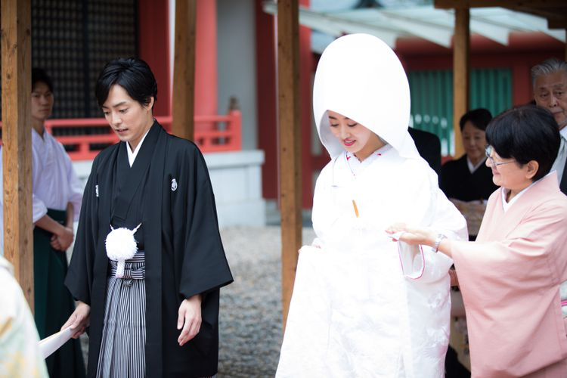

My fathers side of the family is of Japanese descent. I am a quarter asian and want to learn more. I found that there are four major styles for wedding ceremonies. There is Shinto, Christian, Buddist, and non-religious. In the past, it was the [Shinto style wedding](https://japanology.org/2017/08/shinto-weddings-your-complete-guide-to-a-perfect-traditional-japanese-wedding/) that dominated Japan. Through the Christian standard they inhabited the white wedding style even though only 1 percent of Japan is Christian. They adopted things like exchanging rings, bouquet toss, white fancy gowns and honeymoons. Shinto involves many different wedding dress changes. In Shinto the wife starts with a shiromuku. Being dressed in white symbolizes that the bride is ready to start with a blank canvas and accept the groom's ideas and values.

<https://www.brides.com/traditional-japanese-wedding-5091632>

<https://japanology.org/2018/08/traditional-japanese-wedding-dresses-shinto-style/>